Section B — Practical Coding Tasks
Task 1: Grade Band Checker
Build a console program that accepts a student's percentage score and prints their letter grade along with a short motivational message.
- Accept a float percentage value as user input using scanf().
- Assign a grade using if-else if: A (>= 90), B (>= 75), C (>= 60), D (>= 45), F (below 45).
- Print the assigned grade and a one-line message for each band (e.g., 'B — Good work! Keep pushing.').
- Handle invalid input: if the score is outside the range 0–100, print a clear error message and exit the program gracefully
#include <stdio.h>
int main()
{
float percentage;
printf("Enter percentage: ");
scanf("%f", &percentage);
if (percentage < 0 || percentage > 100)
{
printf("Error: Percentage must be between 0 and 100.\n");
return 0;
}
if (percentage >= 90)
printf("Grade A - Excellent work! Keep it up.\n");
else if (percentage >= 75)
printf("Grade B - Good work! Keep pushing.\n");
else if (percentage >= 60)
printf("Grade C - Nice effort! Keep improving.\n");
else if (percentage >= 45)
printf("Grade D - You passed. Work harder.\n");
else
printf("Grade F - Don't give up. Try again.\n");
return 0;
}

Output:
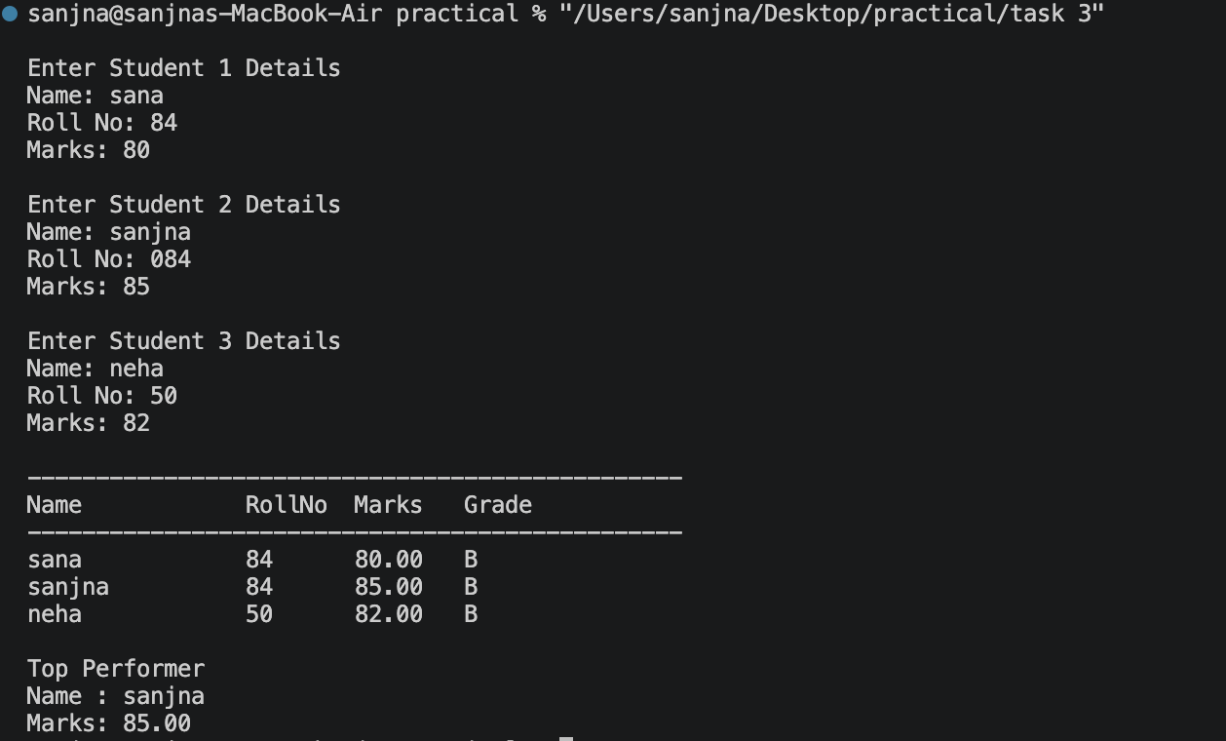

Task 2: Weekly Study Hours Analyser
Build a program that records a student's daily study hours for 7 days, stores them in an array, and generates a performance summary
- Use a for loop to accept 7 float values (one per day) and store them in a float array.
- Calculate and print the weekly total, daily average, and the day number with the highest study hours.
- Print a simple visual bar for each day: the day number followed by one asterisk (*) per hour studied, truncated to the nearest integer (e.g., Day 3: ***).
- Reject and re-prompt for any day entry that is negative or greater than 24, before storing it in the array.
#include <stdio.h>
int main()
{
float hours[7];
float total = 0, average;
int i, highestDay = 0;
for(i = 0; i < 7; i++)
{
do
{
printf("Enter study hours for Day %d: ", i + 1);
scanf("%f", &hours[i]);
if(hours[i] < 0 || hours[i] > 24)
printf("Invalid input! Enter hours between 0 and 24.\n");
} while(hours[i] < 0 || hours[i] > 24);
total += hours[i];
if(hours[i] > hours[highestDay])
highestDay = i;
}
average = total / 7;
printf("\nWeekly Total Hours = %.2f\n", total);
printf("Daily Average = %.2f\n", average);
printf("Highest Study Hours on Day %d\n", highestDay + 1);
printf("\nStudy Hour Chart:\n");
for(i = 0; i < 7; i++)
{
printf("Day %d: ", i + 1);
for(int j = 0; j < (int)hours[i]; j++)
{
printf("*");
}
printf("\n");
}
return 0;
}

Output:
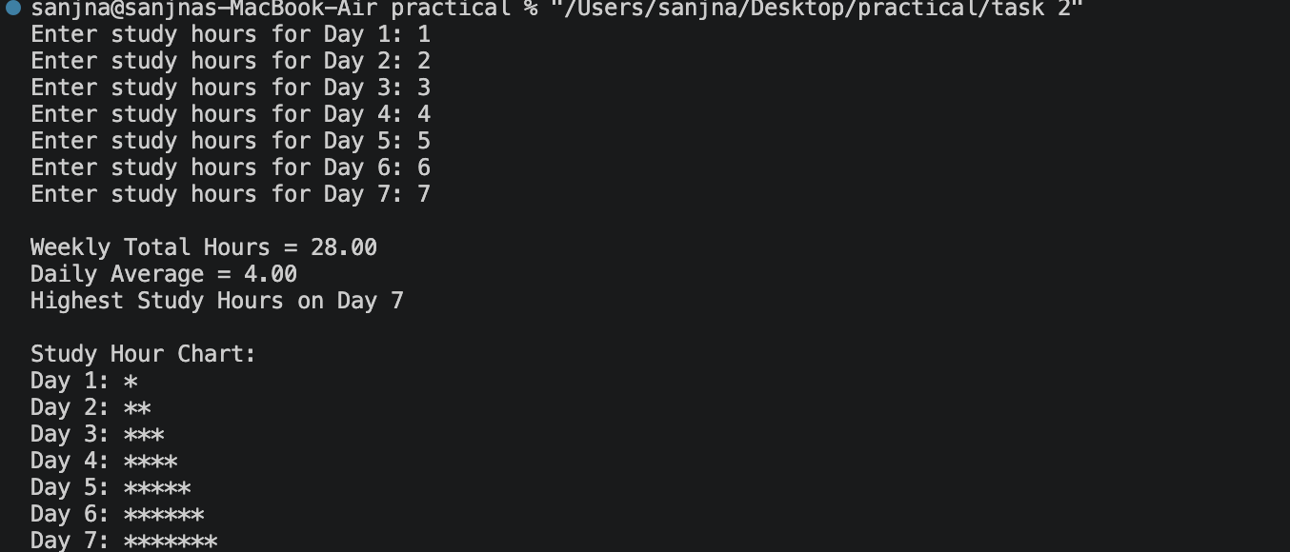

Task 3: Student Record Manager
Build a C program using structures and functions to store, display, and identify the top performer among a group of students.
- Define a struct Student with fields: name (char[50]), rollno (int), marks (float), and grade (char).
- Write a function void assignGrade(struct Student *s) that sets the grade field based on the marks value using the same bands as Task 1.
- In main(), accept data for 3 students, call assignGrade() for each, and display all records in a formatted table with column headers.
- Write a separate function void printTopper(struct Student[], int n) that prints the name and marks of the student with the highest marks.
#include <stdio.h>

struct Student
{
char name[50];
int rollno;
float marks;
char grade;
};

void assignGrade(struct Student *s)
{
if(s->marks >= 90)
s->grade = 'A';
else if(s->marks >= 75)
s->grade = 'B';
else if(s->marks >= 60)
s->grade = 'C';
else if(s->marks >= 45)
s->grade = 'D';
else
s->grade = 'F';
}

void printTopper(struct Student s[], int n)
{
int topper = 0;

for(int i = 1; i < n; i++)
{
if(s[i].marks > s[topper].marks)
topper = i;
}

printf("\nTop Performer\n");
printf("Name : %s\n", s[topper].name);
printf("Marks: %.2f\n", s[topper].marks);
}

int main()
{
struct Student s[3];

for(int i = 0; i < 3; i++)
{
printf("\nEnter Student %d Details\n", i + 1);

printf("Name: ");
scanf("%s", s[i].name);

printf("Roll No: ");
scanf("%d", &s[i].rollno);

printf("Marks: ");
scanf("%f", &s[i].marks);

assignGrade(&s[i]);
}

printf("\n------------------------------------------------\n");
printf("Name\t\tRollNo\tMarks\tGrade\n");
printf("------------------------------------------------\n");

for(int i = 0; i < 3; i++)
{
printf("%s\t\t%d\t%.2f\t%c\n",
s[i].name,
s[i].rollno,
s[i].marks,
s[i].grade);
}

printTopper(s, 3);

return 0;
}

Output:
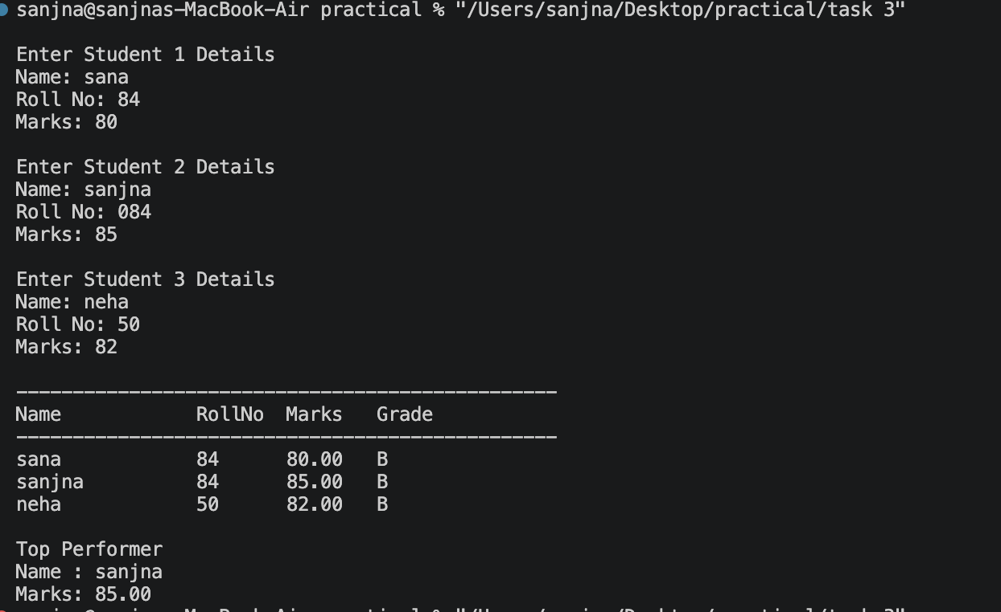

Task 4: Personal Expense Logger
Build a menu-driven C program that lets a user log and view personal daily expenses, and saves all records to a text file on exit.
- Define a struct Expense with fields: category (char[30]) and amount (float). Allocate an array to store up to 10 Expense entries.
- Present a menu with 3 options: (1) Add Expense, (2) View All Expenses, (3) Save & Exit. Loop until the user selects option 3.
- In the View option, display all logged expenses in a formatted list and print the running total at the bottom.
- On exit (option 3), write all expense records to a file named expenses.txt using fprintf(), with one record per line in the format: category,amount.
#include <stdio.h>
#include <string.h>

struct Expense
{
char category[30];
float amount;
};

int main()
{
struct Expense expenses[10];
int count = 0;
int choice;
float total;

do
{
printf("\n===== Personal Expense Logger =====\n");
printf("1. Add Expense\n");
printf("2. View All Expenses\n");
printf("3. Save & Exit\n");
printf("Enter choice: ");
scanf("%d", &choice);

switch(choice)
{
case 1:

if(count < 10)
{
printf("Enter Category: ");
scanf("%s", expenses[count].category);

printf("Enter Amount: ");
scanf("%f", &expenses[count].amount);

count++;
}
else
{
printf("Expense limit reached!\n");
}

break;

case 2:

total = 0;

printf("\nCategory\tAmount\n");
printf("-----------------------\n");

for(int i = 0; i < count; i++)
{
printf("%s\t\t%.2f\n",
expenses[i].category,
expenses[i].amount);

total += expenses[i].amount;
}

printf("-----------------------\n");
printf("Total = %.2f\n", total);

break;

case 3:
{
FILE *fp = fopen("expenses.txt", "w");

if(fp == NULL)
{
printf("Error creating file.\n");
return 1;
}

for(int i = 0; i < count; i++)
{
fprintf(fp, "%s,%.2f\n",
expenses[i].category,
expenses[i].amount);
}

fclose(fp);

printf("Expenses saved to expenses.txt\n");
printf("Exiting program...\n");
break;
}

default:
printf("Invalid choice!\n");
}

} while(choice != 3);

return 0;
}

Output:
